 

**Streamlining Ticket Assignment for Efficient Support Operations**

**Project Overview**

At **ABC Corporation**, the rising number of IT support tickets has made it clear that the current manual ticket allocation process is no longer efficient. The existing approach often results in late responses, tickets being sent to the wrong teams, and uneven workload across staff.

This project addresses these challenges by introducing an **Automated Ticket Assignment System** built on the **ServiceNow platform**. The solution leverages **workflow automation, intelligent routing mechanisms, and role-based access control** to ensure that every ticket is automatically directed to the right team or user, based on predefined conditions such as issue type, category, or priority.

By implementing this solution, ABC Corporation is set to achieve multiple benefits:

* **Operational Efficiency** – Automated routing eliminates repetitive manual work and minimizes the risk of human error.
* **Faster Resolutions** – Tickets reach the right people instantly, enabling quicker responses.
* **Fair Workload Distribution** – Teams receive tickets more evenly, preventing overload on specific individuals.
* **Improved Transparency** – Clear assignment logic and reporting create accountability across support operations.
* **Customer-Centric Service** – Reduced delays and faster problem-solving enhance customer experience.

Ultimately, this project is not just about automation—it is about **transforming IT support operations into a scalable, intelligent, and customer-focused system**. By shifting the effort from administrative tasks to actual problem-solving, support teams can deliver higher-value services, contributing to the company’s overall productivity and service excellence.

**Table of Contents**

1. Introduction
2. Project Goals
3. Core Functionalities
4. ServiceNow Developer Setup
5. Project Development in ServiceNow
6. Output Screenshots
7. Conclusion

**1. Introduction**

As organizations continue to expand their digital operations, the demand for reliable IT support systems grows equally fast. At ABC Corporation, the number of support requests has been steadily climbing, which makes manual assignment of tickets both time-consuming and error-prone. Relying on people to direct tickets often leads to unnecessary delays, routing mistakes, and workload imbalance across teams.

These challenges highlight the need for a smarter, automated approach. Instead of assigning tickets manually, the solution designed in this project uses ServiceNow’s automation features to handle ticket distribution. By applying predefined rules, categories, and logic, each request can be instantly routed to the most appropriate team or specialist, ensuring quick and accurate handling.

The introduction of this system transforms ticket management from a reactive, manual process into a proactive, automated workflow. It reduces dependency on human intervention, speeds up response times, and creates fairness in workload allocation. More importantly, it allows IT teams to focus their efforts on solving issues rather than spending time on administrative steps.

In short, this project demonstrates how automation in ServiceNow can improve efficiency, strengthen accountability, and create a customer-first support model that scales with business growth.

**2. Project Objective**

The main goal of this project is to **develop and implement an automated ticket allocation mechanism** at ABC Corporation that strengthens the overall effectiveness of IT support operations. The system is built to:

* Automatically route tickets to the right team or individual for precise and timely handling.
* Cut down on resolution delays by reducing manual effort and human routing errors.
* Increase customer satisfaction through quicker responses and uniform service quality.
* Ensure better use of resources by evenly distributing workloads among different support teams.
* Improve visibility and accountability by providing clear logic for ticket assignments, along with monitoring and reporting features.

By meeting these objectives, the project will transform the IT support process into a **faster, more dependable, and customer-focused framework**.

**3. Key Features**

* **Smart Routing** – Tickets are automatically directed to the appropriate team or person.
* **Flexible Rules** – Routing logic can be configured based on priority, issue type, or category.
* **Workload Distribution** – Balances the ticket load evenly across available staff.
* **Escalation Handling** – Automatically escalates tickets that are at risk of breaching SLAs.
* **Instant Notifications** – Sends real-time alerts to ensure quicker acknowledgment and response.
* **Performance Insights** – Provides analytics and reports on ticket movement and team performance.

**4. ServiceNow Developer Setup**

To build and test applications in ServiceNow, you need to set up a **developer environment**. The steps are as follows:

1. Visit the Service now developer website (<https://developer.servicenow.com/dev.do>).

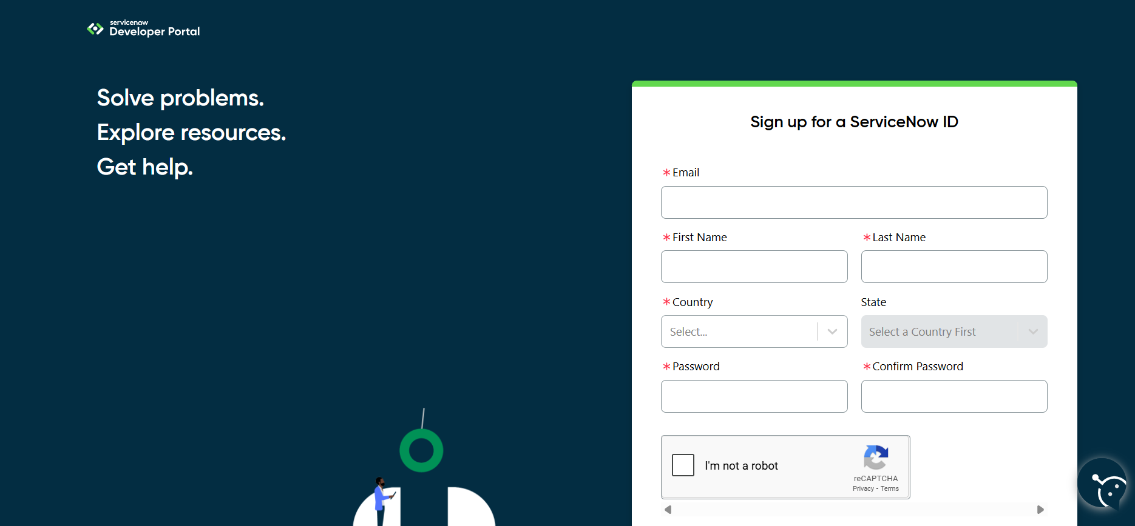

1. Sign up for a free developer account by providing the required details.
2. Once registered, you’ll receive a verification email. Confirm your account through the email link.
3. After successful verification, your Developer Portal Dashboard will be available.
4. From here, click on “Start Building” to access options for requesting a Personal Developer Instance (PDI) or to explore tools like App Engine Studio.

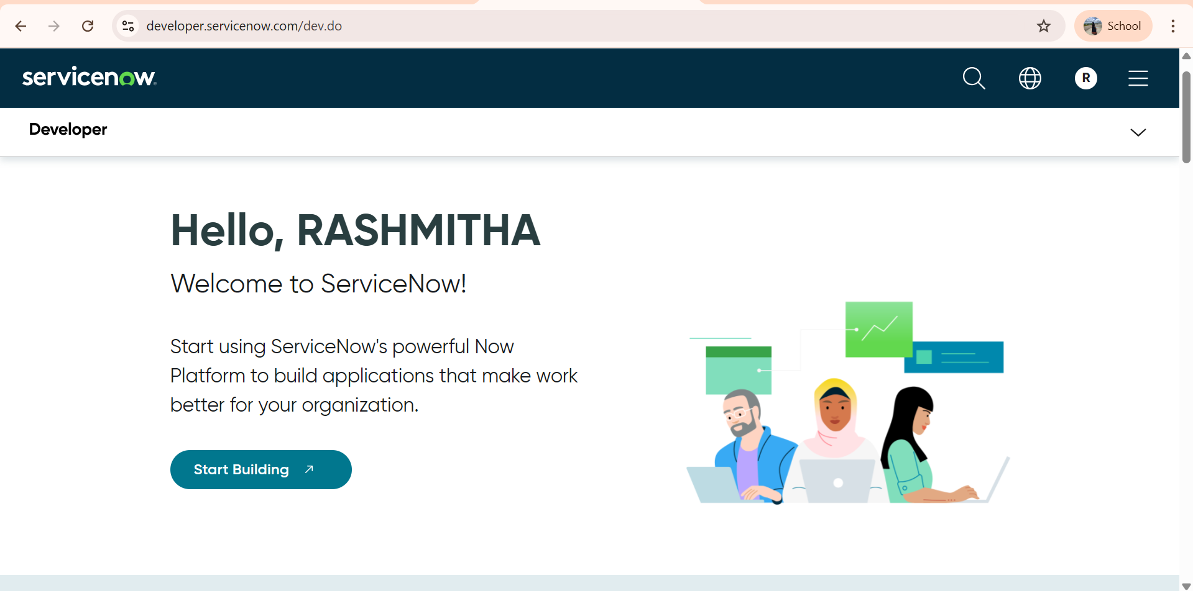

1. Using the profile icon in the top-right corner, you can manage your account, request new instances, and view your developer profile.

This setup provides a **dedicated sandbox environment** where you can safely practice, design, and implement ServiceNow applications without affecting live systems.

**5. Project Implementation in ServiceNow**

Once the instance is ready, you will be redirected to **Creator Studio**. This workspace offers a guided, no-code environment where you can quickly design and deploy applications. It is especially useful for **form-based applications** that involve creating tables, defining fields, and automating workflows.

1. **Creating Users**

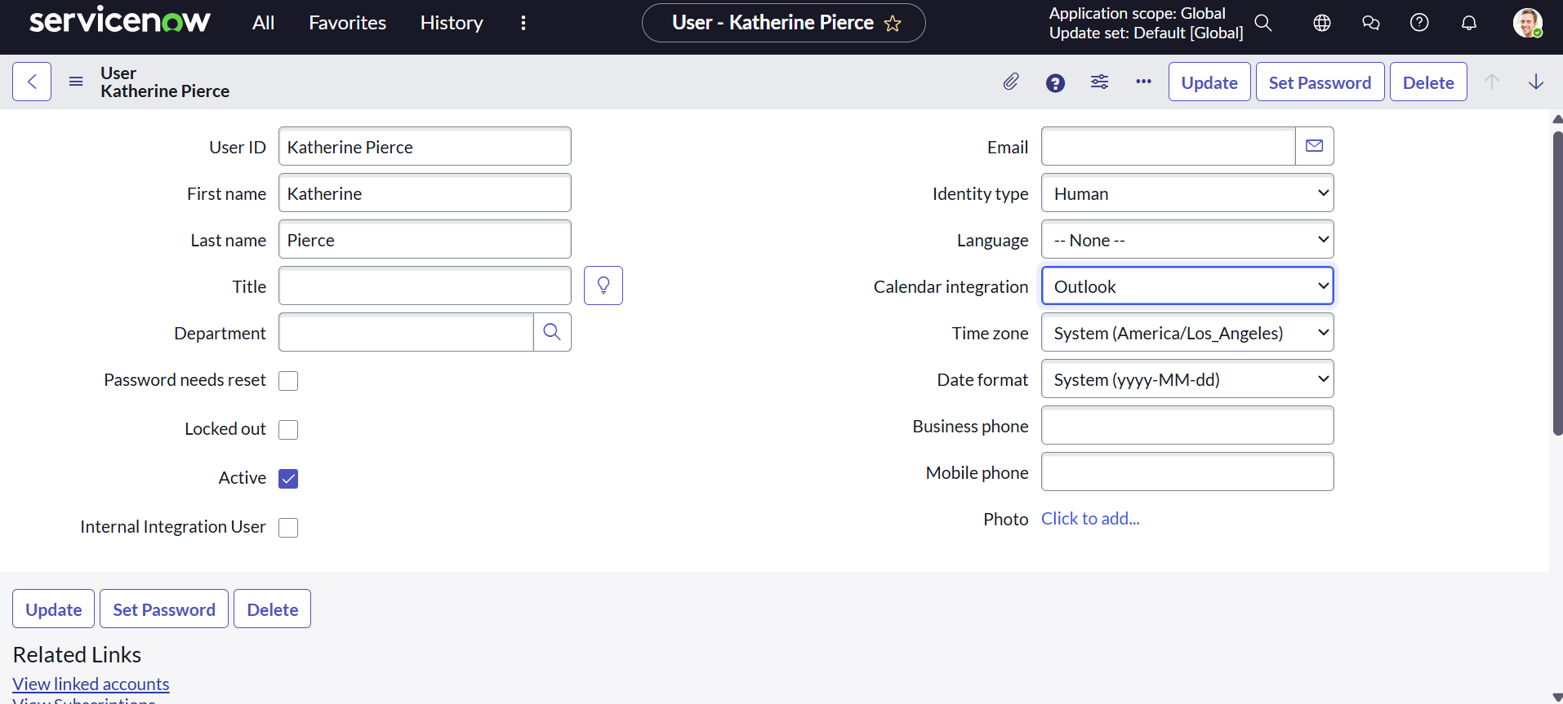

1. From the left navigation menu, click on All search for **Users**.
2. Under **System Security**, select **Users**.
3. Click **New** to add a user record.
4. Enter the necessary information (First Name, Last Name, User ID, Email, Password, and Roles).
5. Click **Submit** to save the record.

**Create another user:**

1. To add another user, repeat the same process with different details
2. Click **Submit** again to save the second user and save it again.

**b. Creating Groups**

1. In the navigation panel, Click on All search for **Groups**.
2. Under **System Security**, choose **Groups**.
3. Select **New** to create a group.
4. Provide the required information:
   * **Name** → Enter the group’s name.
   * **Description** → Short explanation of the group’s purpose.
   * **Manager** → Assign a manager if necessary.
5. Click **Submit** to save the group.

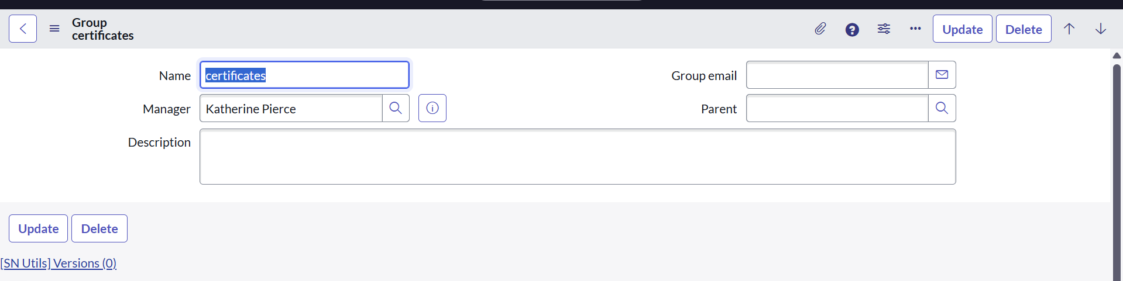

**Creating another group**

1. To create another group, repeat the same process with different details
2. Click **Submit** again to save the second group and save it again.

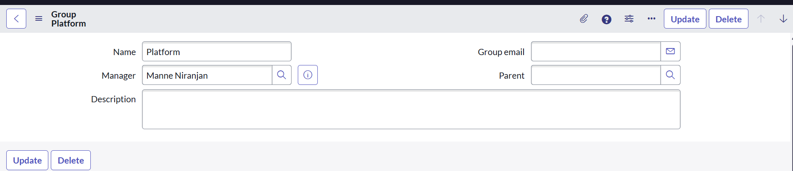

**C. Creating Roles**

1. From the left navigation menu, click on All and search for **Roles**.
2. Under **System Security**, open **Roles**.
3. Click **New** to create a role.
4. Fill in the details:
   * **Name** → A unique identifier (e.g.,Certificate_role ).
   * **Description** → A brief note about the role’s responsibility (e.g., handles certificate-related issues).
5. Click on Submit to Save the role

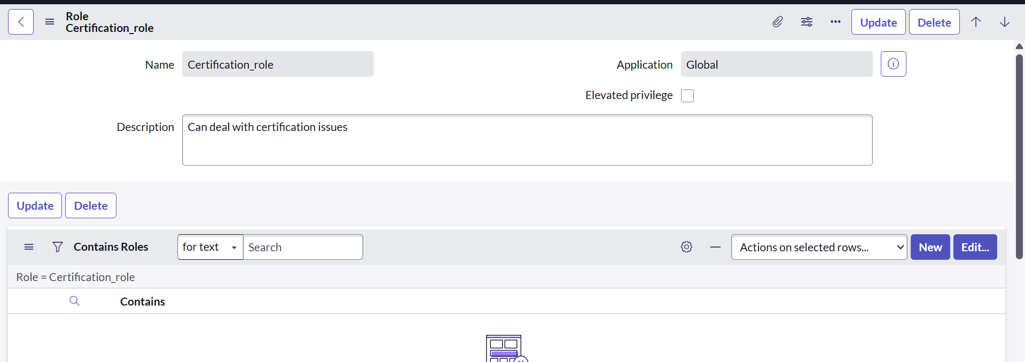

**Creating another roles**

1.To create another role, repeat the same process with different details as Role name as Platform_role and with suitable description

3. Click **Submit** again to save the second role and save it again.

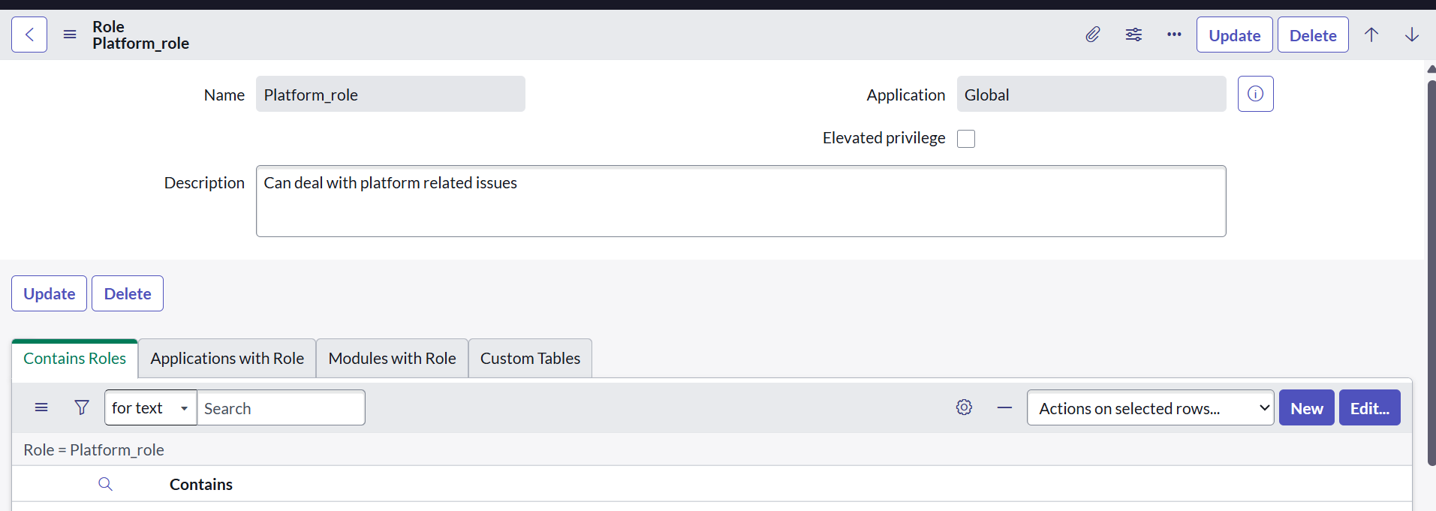

**d. Creating a Custom Table**

1. In the navigation panel,click on all and search for **Tables**.
2. Under **System Definition**, click on **Tables.**

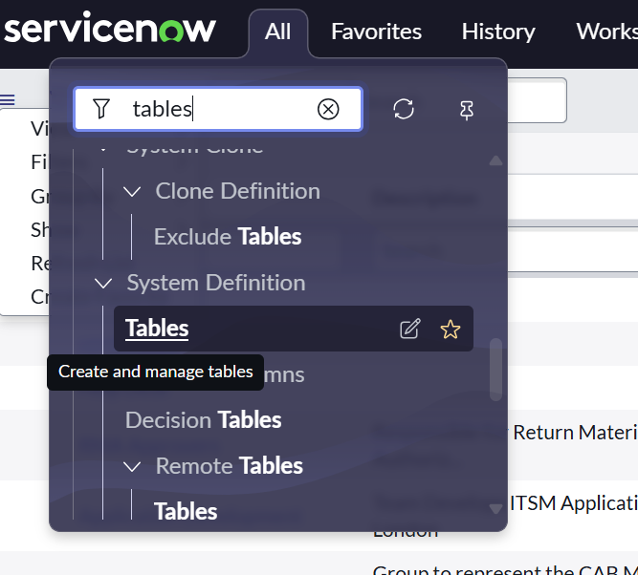

1. Click **New** to create a new table.
2. Provide the table details:
   * **Label** → *Operations Related*
   * Enable **Create Module** and **Create Mobile Module**.
   * **Menu Name** → *Operations Related*

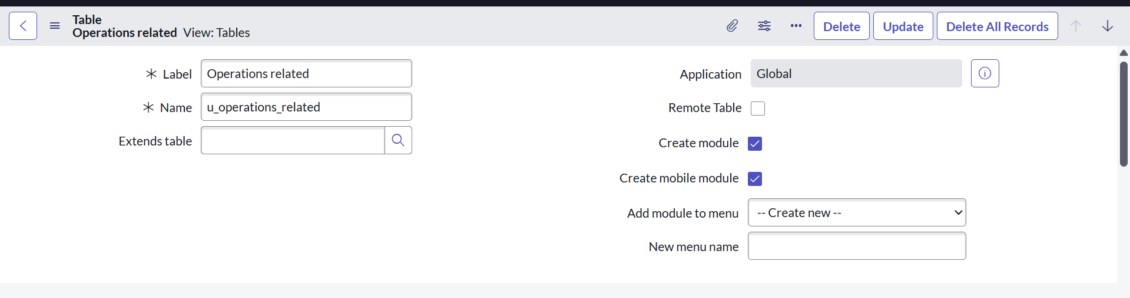

1. Add columns such as *Issue, Description, Assigned To, and Status*.
2. Save the table.

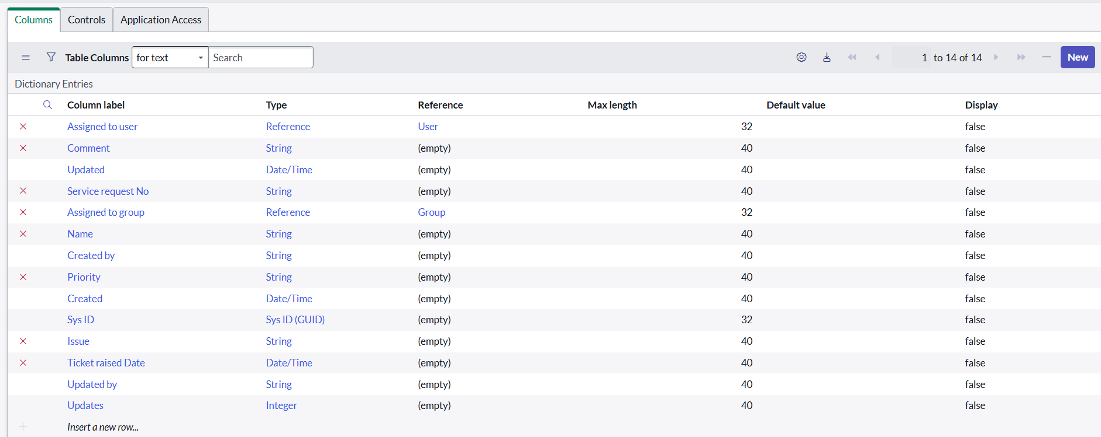

This table will act as the **central storage** for all tickets in the project. It ensures that requests are captured in a structured way and can be routed automatically to the right team.

**Adding Choices to the Issue Field**

1. Open the newly created table and go to **Form Design**.
2. Select the **Issue** field.
3. Add the following predefined options:
   * Unable to login to platform
   * 404 error
   * Certificate related
   * User expired

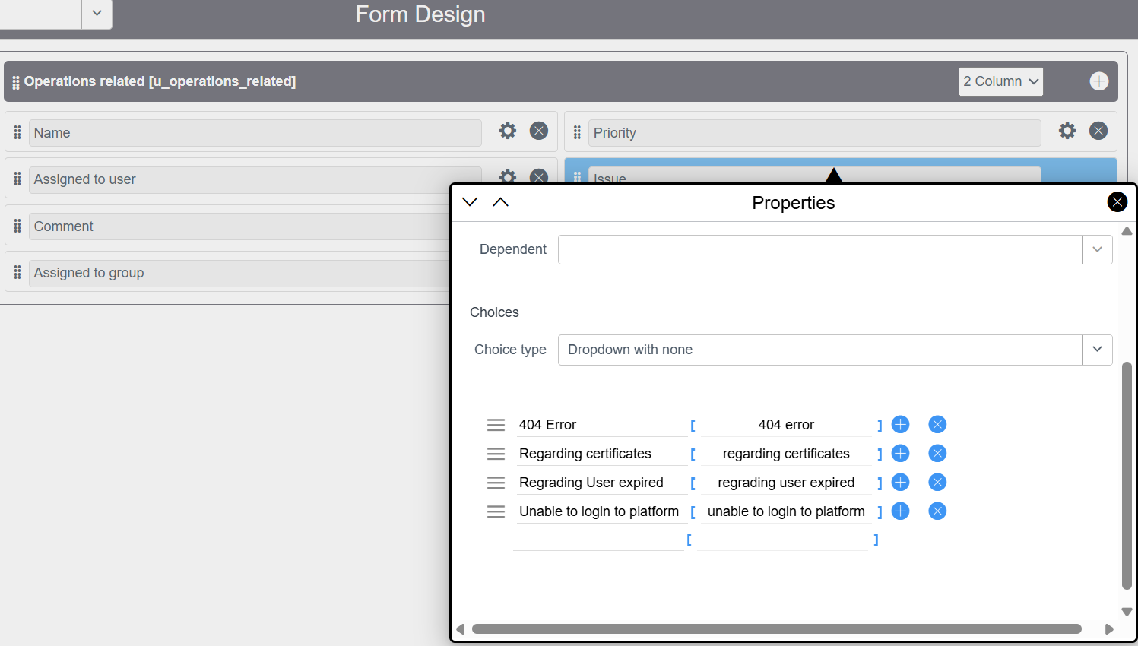

1. Save the design.

Standardizing issue types with predefined choices avoids ambiguity (e.g., “login issue” vs. “can’t login”) and makes automation rules easier to configure for ticket routing

**e. Assigning Users and Roles to Groups**

**i. Linking Users and Roles to the Certificate Group**

1. In the left navigation bar, search for **Groups**.
2. Under **System Security**, open the **Groups** option.
3. Select the **Certificates Group** that was previously created.
4. Inside the **Group Members** tab:
   * Click **Edit**.
   * Add **Katherine Pierce** as a member.
   * Save the changes.

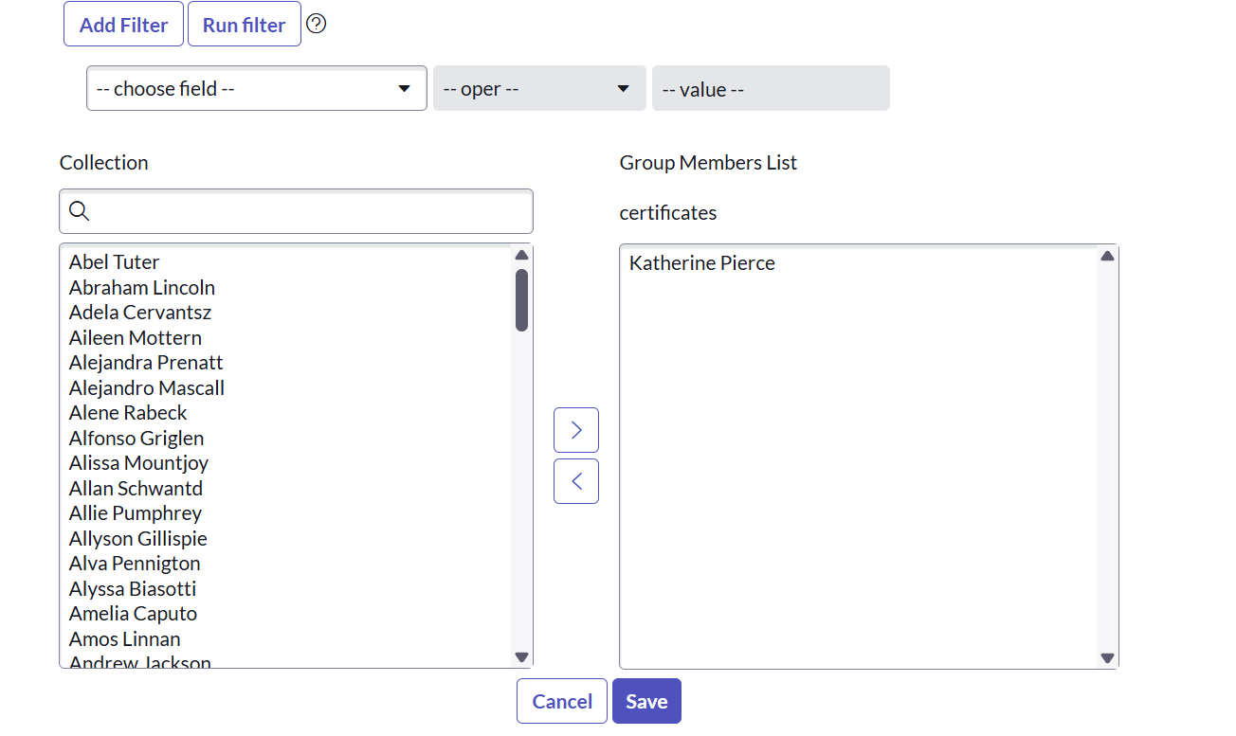

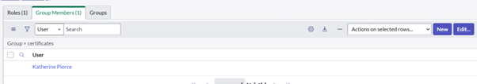

1. In the **Roles** tab:
   * Click **Edit**.
   * Assign the **Certificate_role** to the group.
   * Save the changes.

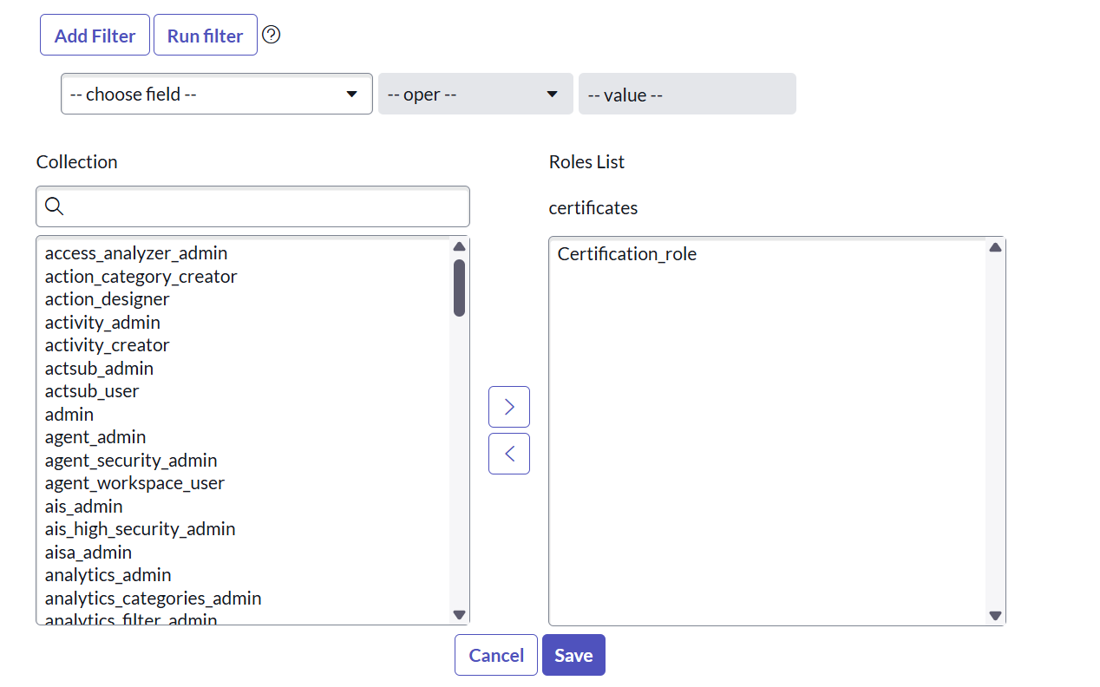

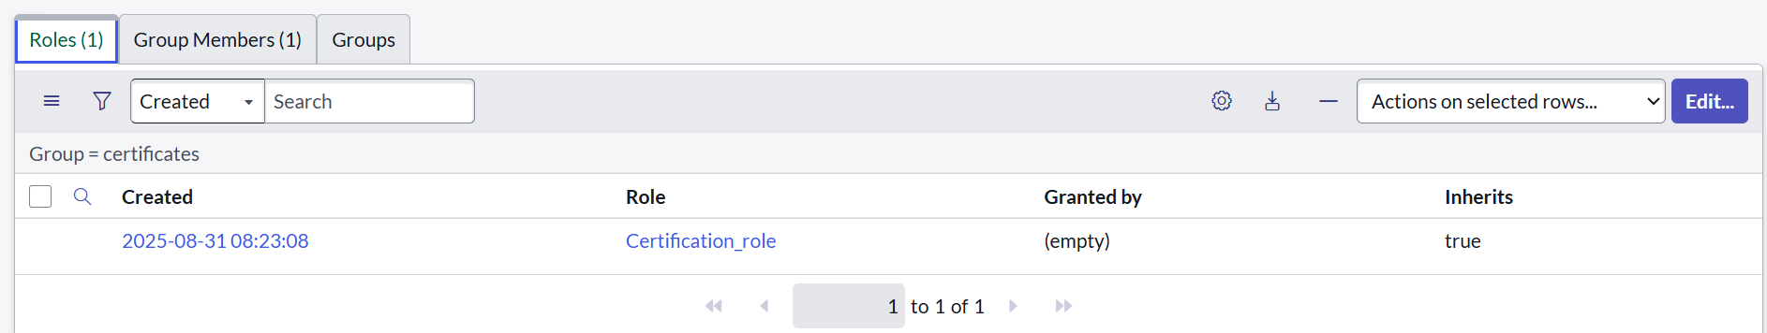

Assigning users and roles to the Certificate Group ensures that only the right people are authorized to manage certificate-related tickets. This not only enforces **access control** but also makes the automated assignment work effectively.

**ii. Linking Users and Roles to the Platform Group**

1. From the left navigation panel,click on all search for **Groups**.
2. Under **System Security**, select **Groups**.
3. Open the **Platform Group** created earlier.
4. Within the **Group Members** tab:
   * Click **Edit**.
   * Add **Manne Niranjan** from the available users.
   * Save the record.

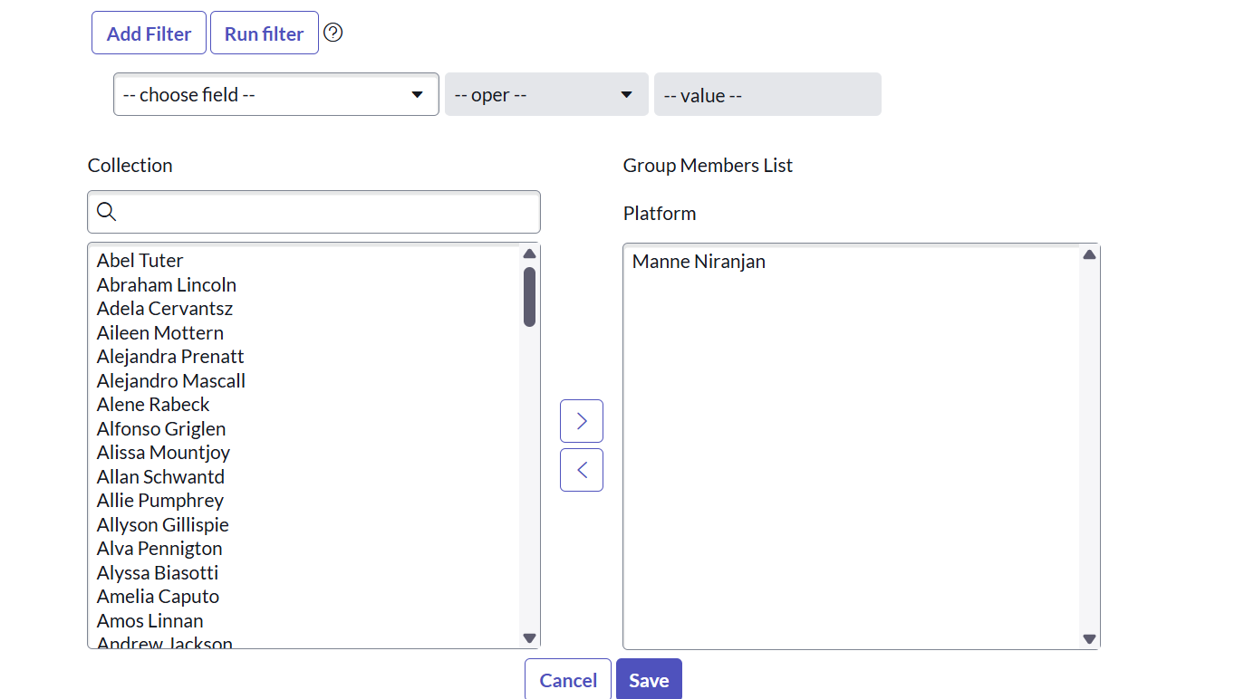

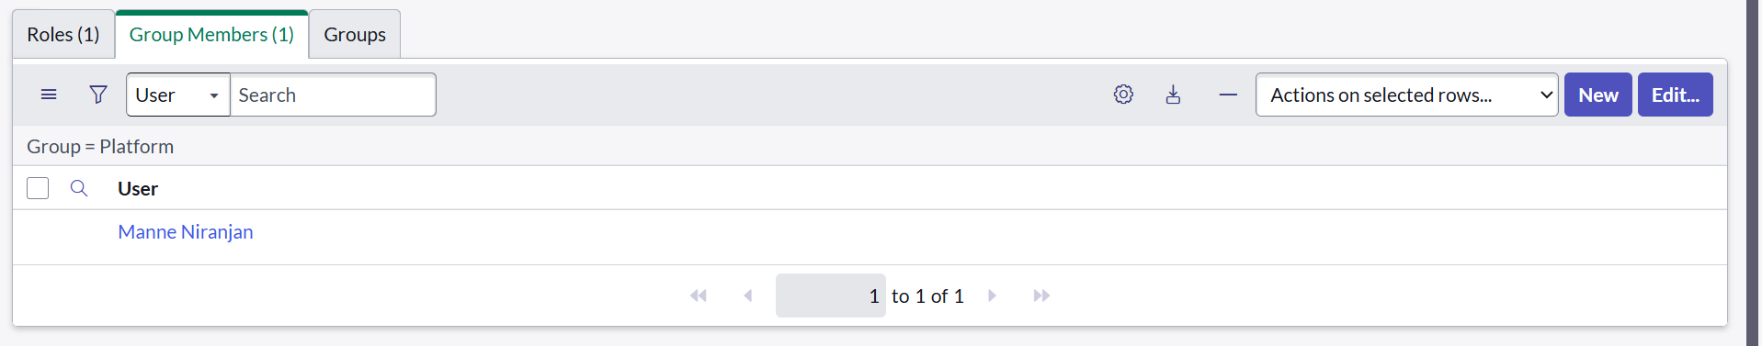

1. In the **Roles** tab:
   * Click **Edit**.
   * Assign the **Platform_role**.
   * Save the changes.

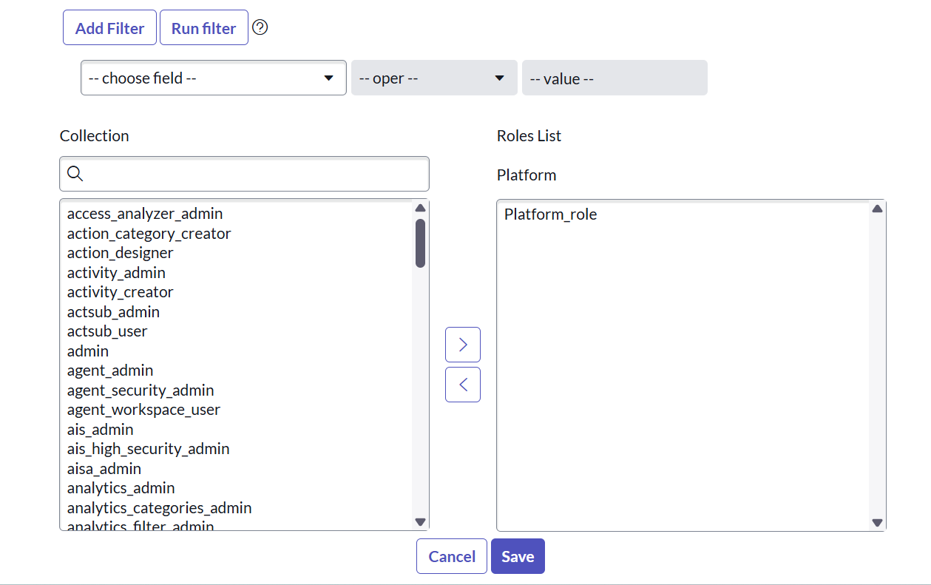

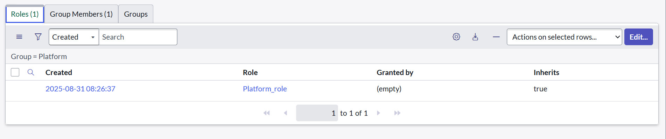

This setup ensures that platform-related issues are only handled by the assigned group members, providing **clarity and accountability** in ticket handling.

**f. Assigning Roles to the Table**

1. Go to the left navigation bar click on all and search for **Tables**.
2. From the list, select the **Operations Related** table.
3. Navigate to the **Application Access** tab.
4. Elevate your privileges by selecting your profile → **Elevate Role → security_admin → Update**.

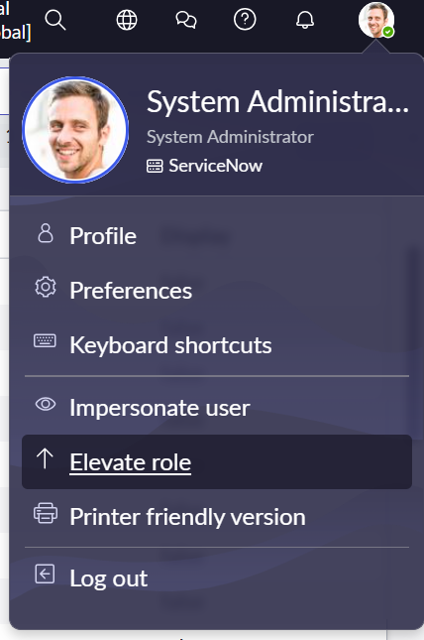

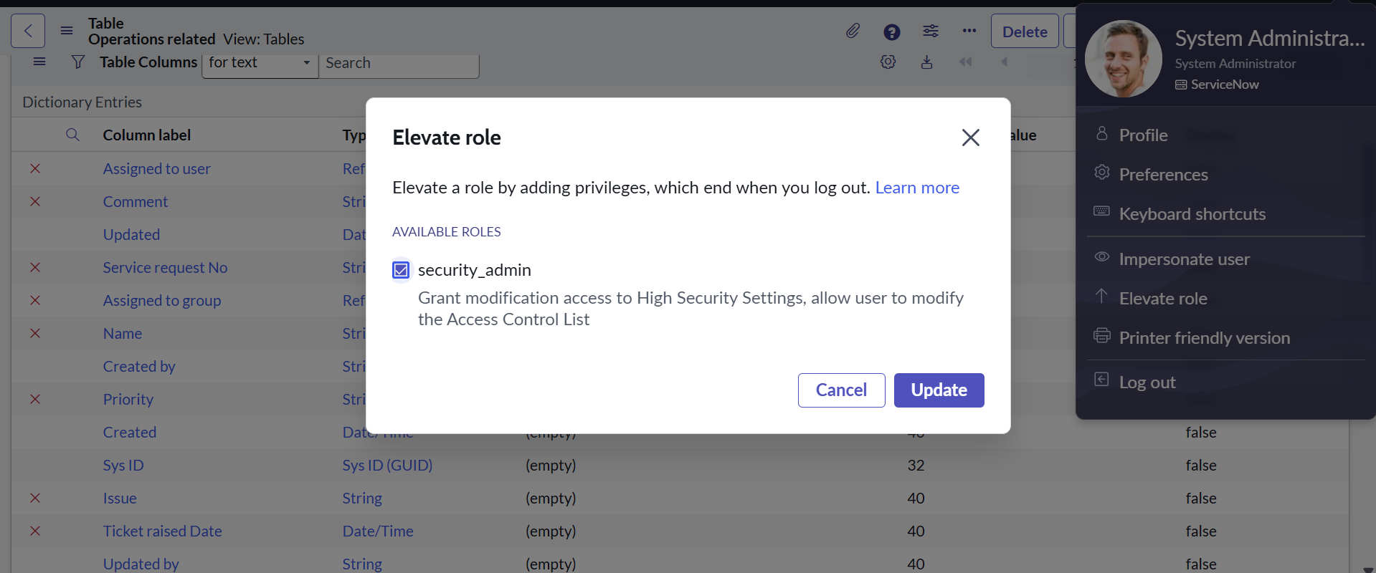

1. Under **u_operations_related [Read]**:
   * In **Requires Role**, insert a new row.
   * Add **Platform_role** and **Certificate_role**.
   * Save the changes.

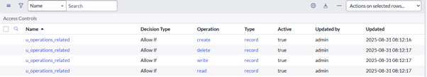

1. Under **u_operations_related [Write]**:
   * Repeat the same steps and add **Platform_role** and **Certificate_role**.
   * Save the changes.

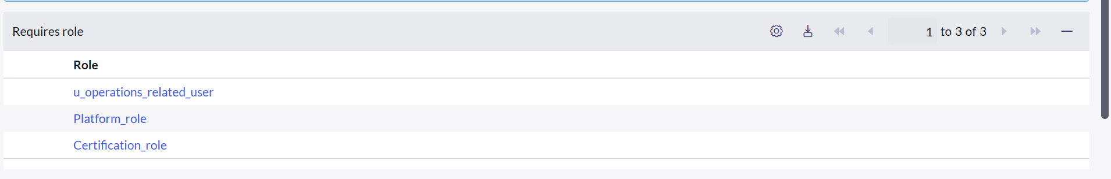

By restricting **read/write permissions** to specific roles, only authorized users can access and modify records in the Operations Related table. This ensures **data security and controlled access**, making sure that tickets are handled only by the intended groups.

**g. Creating Access Control Rules (ACLs)**

1. Log into your **Personal Developer Instance (PDI)** in ServiceNow.
2. In the navigation menu, search for **ACL**.
3. Under **System Security**, select **Access Control (ACL)**.
4. Click **New** to create a new rule.
5. Fill out the necessary details (such as **Table, Operation, and Field**).

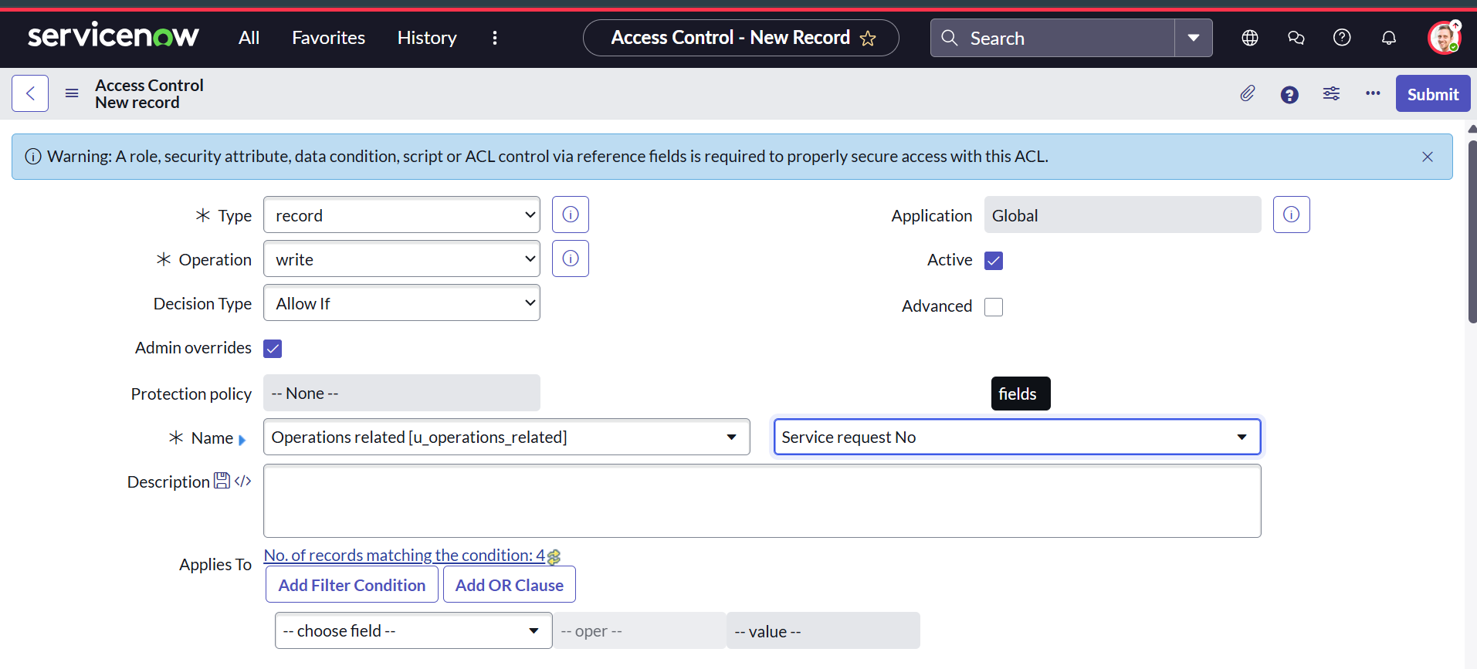

1. In the **Requires Role** section:
   * Insert a new row.
   * Add the **admin role**.

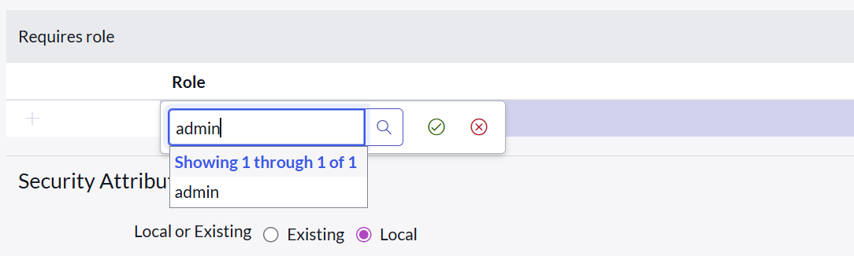



1. Save the ACL.

Repeat this process to create ACLs for the following fields:

* **Issue**
* **Priority**
* **Ticket Raised Date**

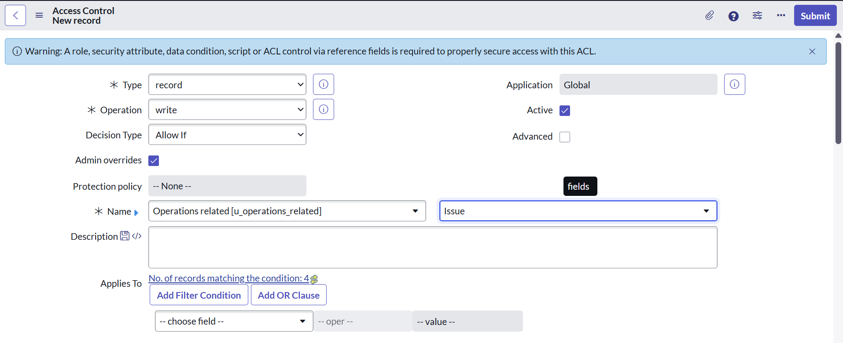

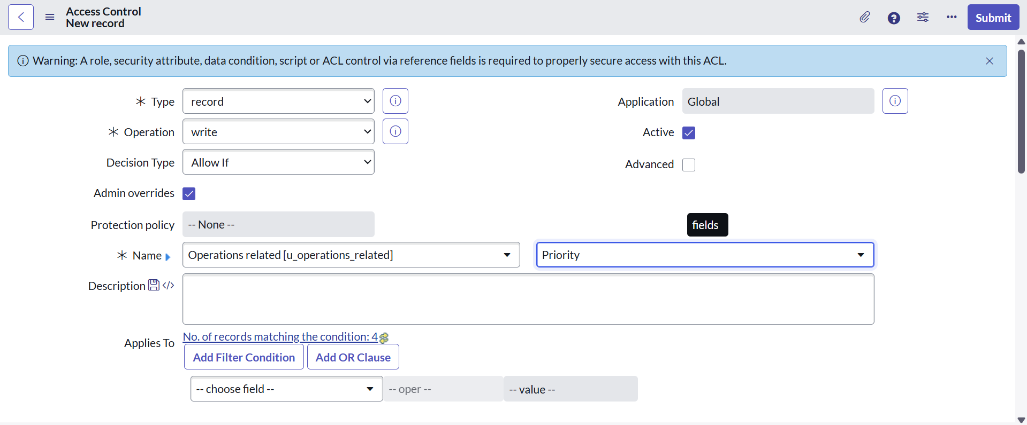

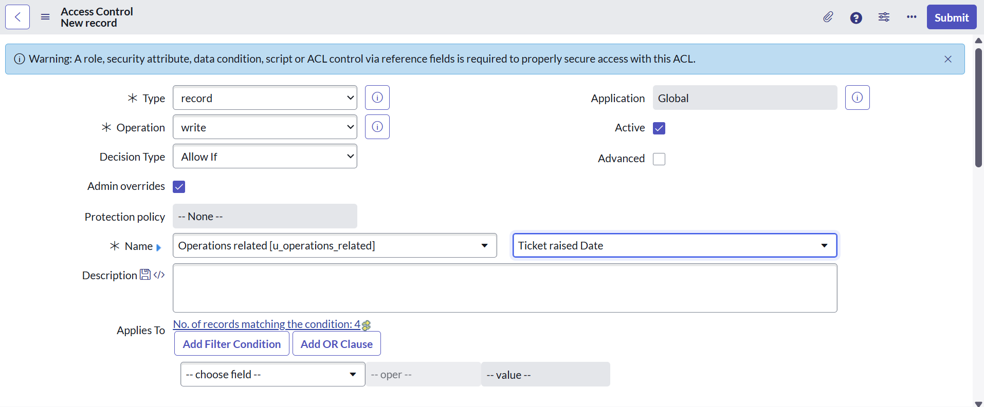

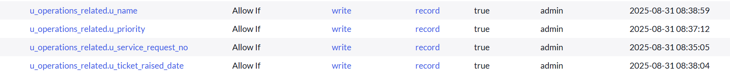

ACLs provide **fine-grained security** by defining who can read or modify specific fields or tables. Setting up these controls ensures that sensitive data is protected and only accessible to users with the proper authorization

**h. Flow Designer Automation**

**i. Building a Flow for Certificate Tickets**

1. Log in to your ServiceNow instance.
2. From the left navigation bar, search for **Flow Designer** under *Process Automation*.

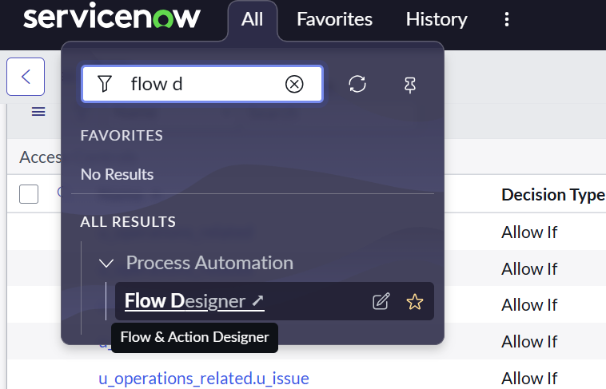

1. Click **New → Flow** to create a new workflow.

**Set Flow Properties:**

* **Flow Name:** Certificate Issues
* **Application:** Global
* **Run As:** System User
* Click **Submit**.

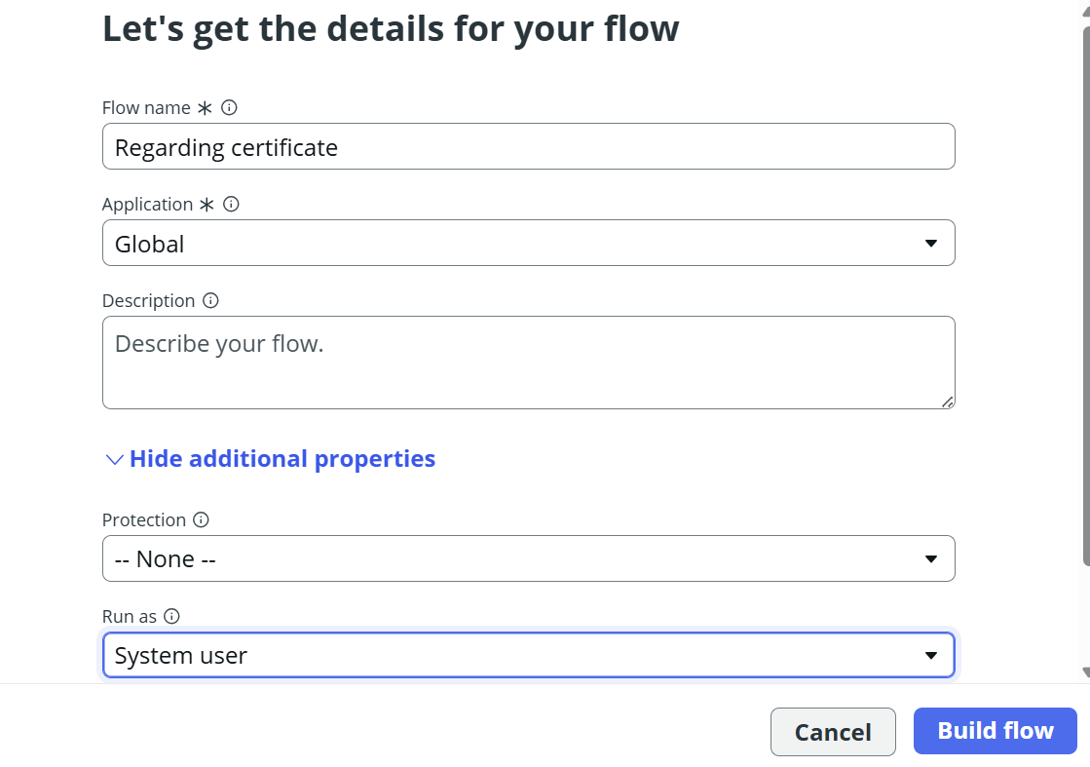

**Add Trigger:**

1. Select **Add Trigger**.
2. Choose **Create or Update Record**.
3. Configure as follows:
   * **Table:** Operations Related
   * **Condition:**
     + Field: Issue
     + Operator: is
     + Value: Certificate related
4. Click on done and Save the trigger.

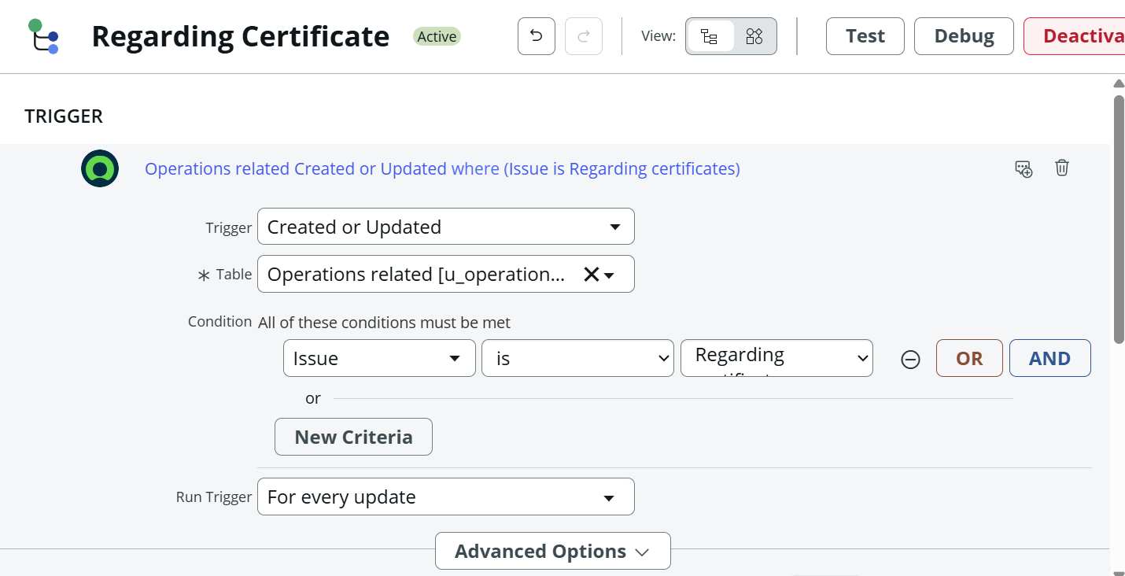

**Add Action:**

1. Select **Add Action**.
2. Choose **Update Record**.
3. Configure the update:
   * Table: Auto-selected from trigger
   * Field: Assigned to Group
   * Value: Certificates Group
4. Click on done and Save the action.

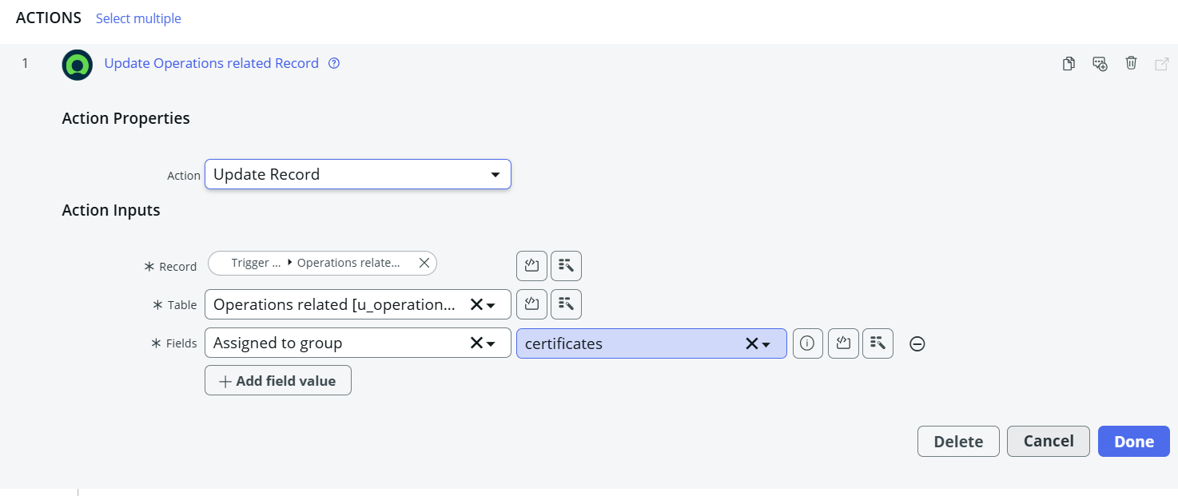

**Finalize:**

* Click **Save** to save the flow and then **Activate** the flow to enable it.

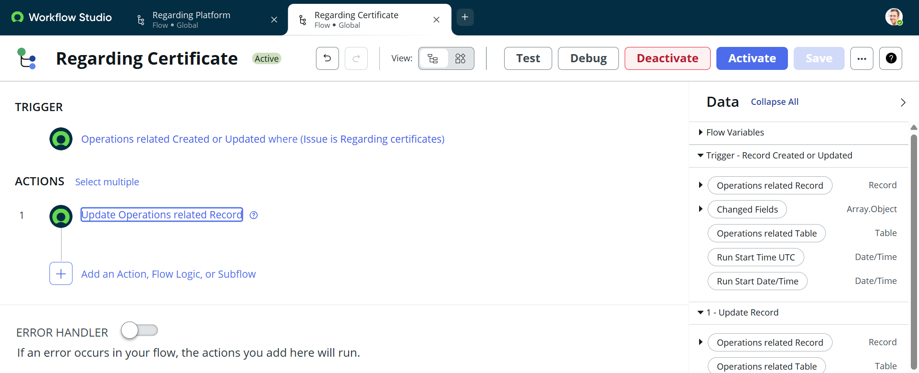

With this flow active, any ticket logged under “Certificate-related issues” is instantly routed to the **Certificate Group**, eliminating the need for manual assignment and ensuring faster resolution.

### **ii. Create a Flow to Assign operations ticket to Platform group:**

1. **Open ServiceNow** and log in to your instance.
2. In the left navigation panel, click on **All** → search for **Flow Designer**.
3. Select **Flow Designer** under *Process Automation*.
4. Once Flow Designer opens, click on **New** → select **Flow**.

Create a new flow with the following properties:

* + **Flow Name:** Platform Issues
  + **Application:** Global
  + **Run As:** System User
  + Save the configuration.

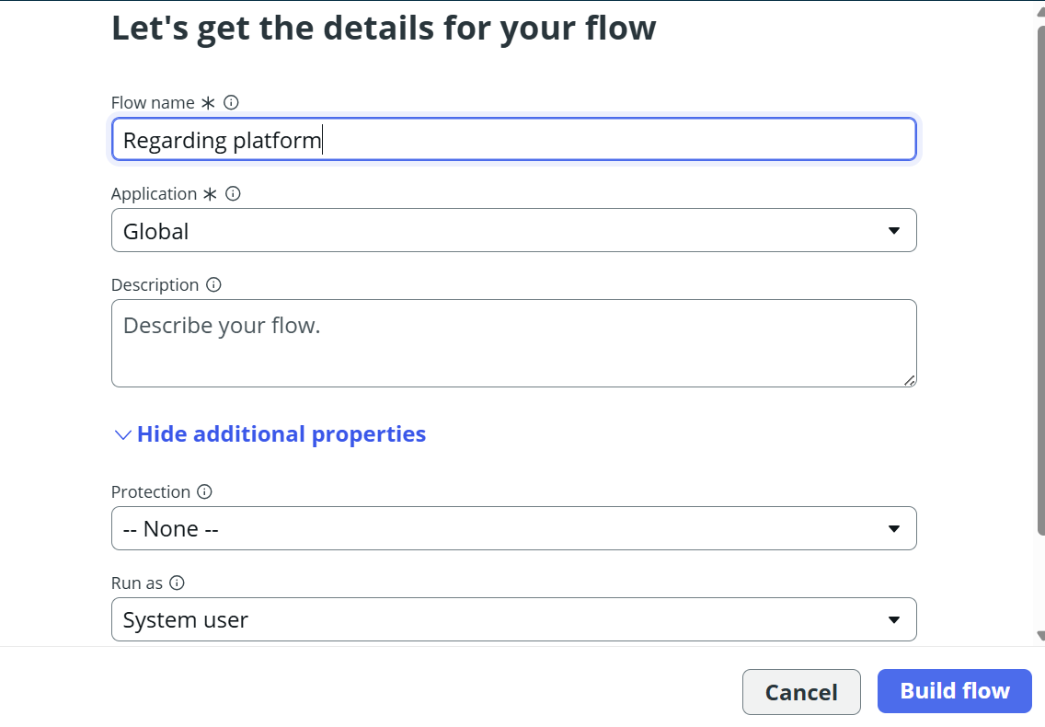

**Add Trigger:**

1. Click **Add a trigger**.
2. Search and select **Create or update a record**.
3. Configure the trigger:
   * **Table:** *Operations related*
   * **Conditions:**
     + *Field:* Issue → *is* → *Unable to login to platform*
     + Click **New Criteria** → *Issue → is → 404 Error*
     + Click **New Criteria** → *Issue → is → Regarding User expired*
4. Click **Done**

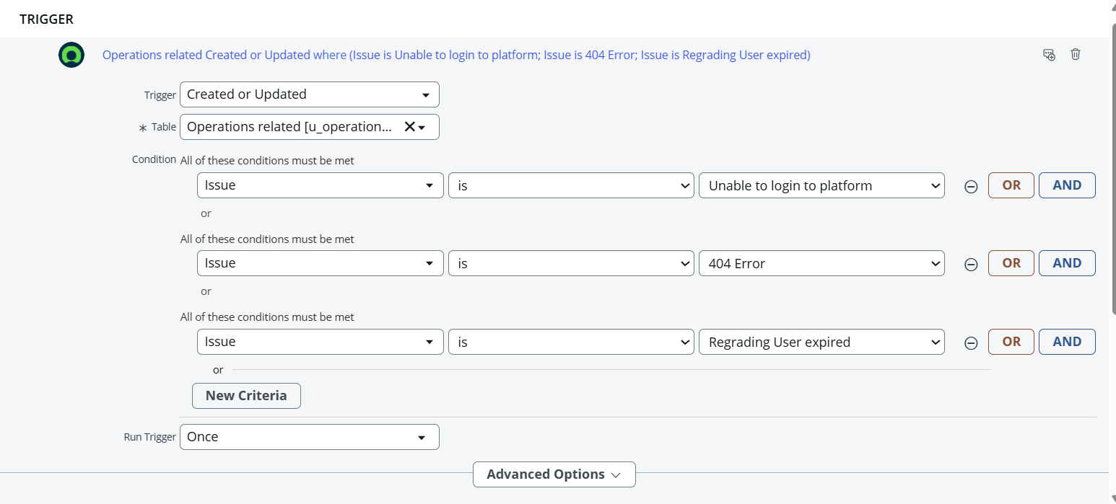

**Add Action:**

1. Click **Add an action**.
2. Search for **Update Record** and select it.
3. In the **Record field**, drag the fields from the **Data Panel** on the left.
4. Configure the update:
   * **Table:** *Auto-assigned from trigger*
   * **Field:** Assigned to Group
   * **Value:** Platform
5. Click **Done**

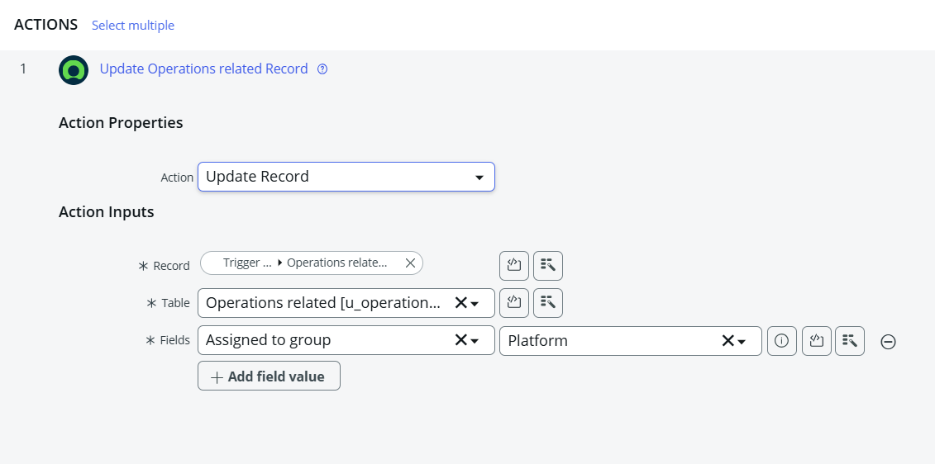

**Finalize:**

* Click **Save** to save the flow and then **Activate** the flow to enable it.

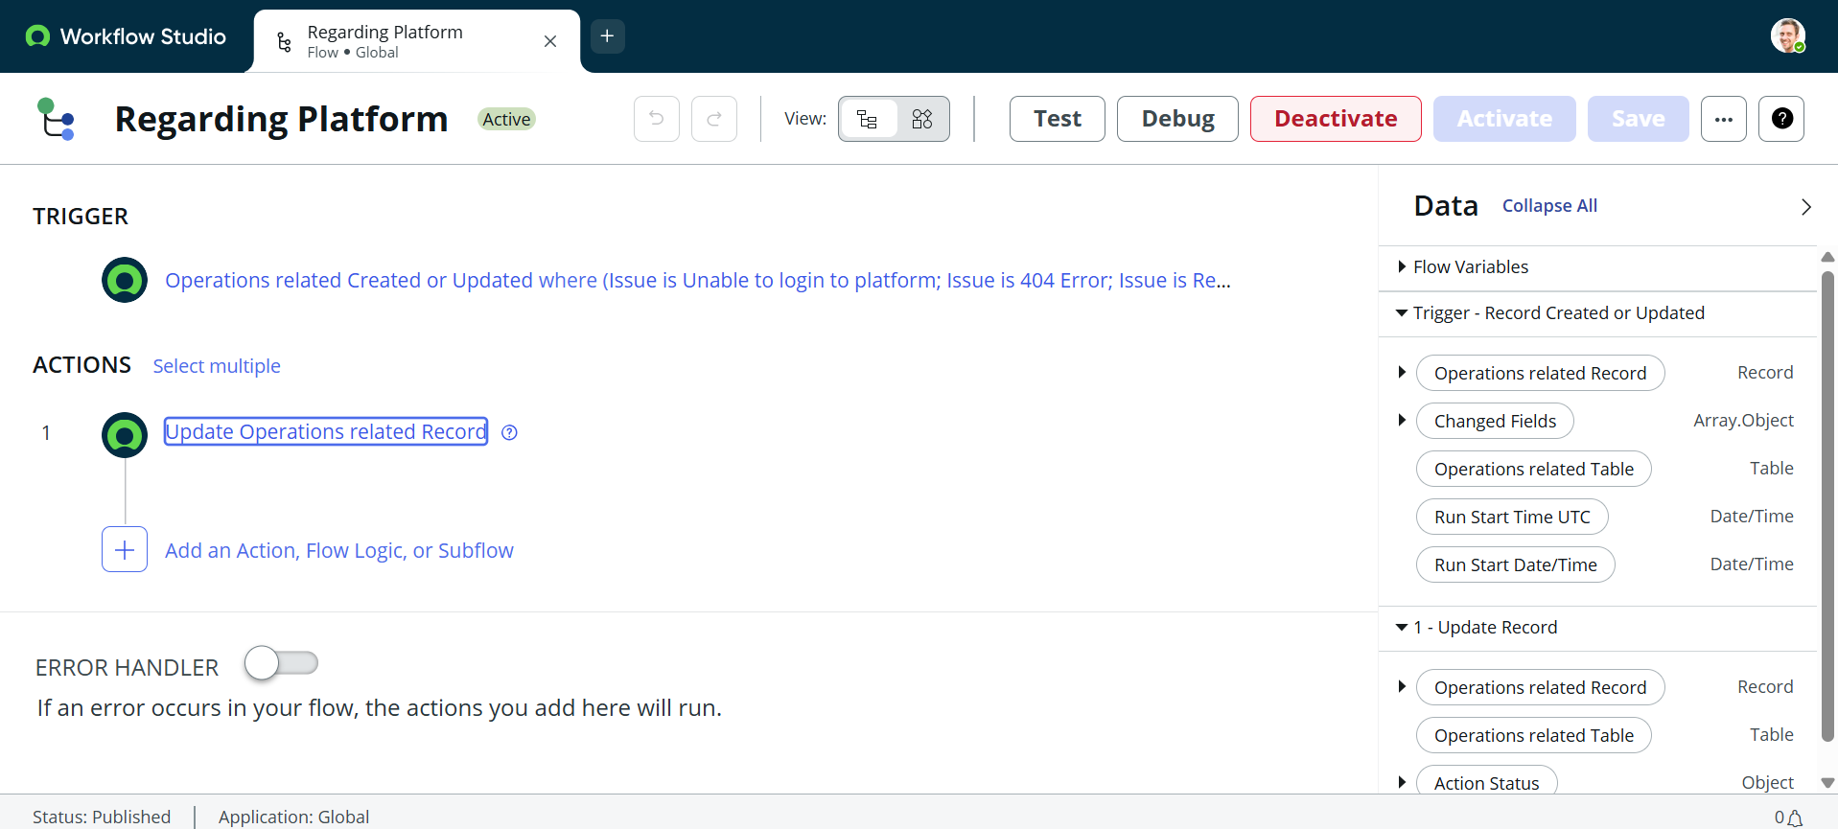

This workflow ensures that tickets marked with issues like “Login problems,” “404 error,” or “User expired” are automatically routed to the **Platform Group**. This reduces human effort, avoids delays, and guarantees that tickets land in the right queue.

**6. Outputs of Screenshots**

After setting up the flows in ServiceNow, the automation works as intended:

* When a ticket is created in the **Operations related** table with the issue **“Regarding Certificates”**, it is **automatically assigned** to the **Certificates group**.
* When a ticket is created with issues like **“Unable to login to platform”**, **“404 Error”**, or **“Regarding User expired”**, it is **automatically assigned** to the **Platform group**

This confirms that the automation logic routes tickets without manual effort, leading to consistent and efficient handling.

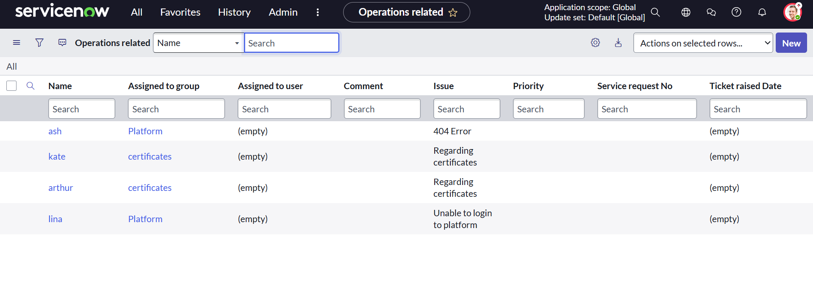

**7. Conclusion**

The introduction of automated ticket assignment in ServiceNow has **transformed the support operations** at ABC Corporation. Using Flow Designer, tickets are now intelligently categorized and routed based on their issue type. This change has:

* **Accelerated response times** → Tickets immediately reach the correct support team.
* **Improved accuracy** → The chance of tickets being misrouted is minimized.
* **Enhanced efficiency** → Workloads are balanced, and resources are better utilized.
* **Increased customer satisfaction** → Faster resolutions create a better support experience.

By combining user management, groups, roles, tables, ACLs, and flows, the system ensures that support staff focus on **resolving problems** instead of handling administrative tasks.

In essence, this project proves how ServiceNow can streamline IT Service Management (ITSM) by automating routine processes and ensuring a more **reliable, transparent, and customer-driven support system**.

<https://github.com/rashmitha-35/streamlining-ticket-assignment-for-efficient-support-operations->